COS 226 Algorithms and Data Structures Spring 2008

Midterm
This test has 8 questions worth a total of 80 points. You have 80 minutes. The exam is closed book, except that you are allowed to use a one page cheatsheet. No calculators or other electronic devices are permitted. Give your answers and show your work in the space provided. Write out and sign the Honor Code pledge before turning in the test.
“I pledge my honor that I have not violated the Honor Code during this examination.”
Problem | Score
1
2
3
4
Sub 1

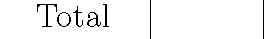
Problem | Score
5
6
7
8
Sub 2

Name:
Login ID:
Precept: P01 12:30 Moses P01A 12:30 Szymon P02 1:30 Szymon P02A 1:30 Moses P03 3:30 Nadia
1
1. 8 sorting algorithms. (16 points) The column on the left is the original input of strings to be sorted; the column on the right
are the string in sorted order; the other columns are the contents at some intermediate step during one of the 8 sorting algorithms listed below. Match up each algorithm by writing its
number under the corresponding column. Use each number exactly once.
null | hash | fifo | list | type | find | hash | find | exch | exch
type | heap | next | heap | tree | hash | null | hash | fifo | fifo
null | fifo | null | fifo | swim | heap | null | heap | find | find
hash | link | hash | exch | swap | lifo | type | link | hash | hash
null | list | null | next | push | link | heap | list | heap | heap
heap | next | heap | leaf | swap | list | link | null | leaf | leaf
sort | find | exch | find | swap | null | null | null | left | left
link | lifo | link | hash | null | null | sort | null | less | less
list | exch | list | node | list | null | find | push | lifo | lifo
push | leaf | less | left | path | null | list | sort | link | link
find | less | find | less | less | null | push | swap | list | list
swap | left | left | lifo | null | push | swap | type | next | next
null | node | node | null | sink | root | lifo | null | null | node
null | null | leaf | null | null | sort | null | null | null | null
root | null | lifo | null | sort | swap | null | root | root | null
lifo | null | null | link | null | type | root | lifo | null | null
swap | null | swap | null | link | exch | leaf | swap | swap | null
leaf | null | null | push | leaf | fifo | path | leaf | null | null
tree | null | tree | root | hash | leaf | swap | tree | tree | null
path | null | path | null | null | left | tree | path | path | null
node | null | null | null | node | less | exch | node | node | null
left | path | swap | sink | left | next | left | left | sort | path
less | tree | push | sort | find | node | less | less | push | push
exch | swap | sort | null | exch | null | node | exch | null | root
null | sink | null | null | null | null | null | null | null | sink
sink | swim | sink | swap | heap | null | null | sink | sink | sort
swim | root | swim | swim | null | path | sink | swim | swim | swap
null | swap | null | path | null | sink | swim | null | null | swap
next | swap | type | swap | next | swap | fifo | next | swap | swap
swap | push | swap | type | root | swap | next | swap | swap | swim
fifo | sort | null | tree | fifo | swim | null | fifo | type | tree
null | type | root | swap | lifo | tree | swap | null | null | type
--- | --- | --- | --- | --- | --- | --- | --- | --- | ---
0 |  |  |  |  |  |  |  |  | 1

(0) Original input | (4) Shellsort | (7) Quicksort
(1) Sorted | (13-4-1 increments) | (standard, no shuﬄe)
(2) Selection sort | (5) Mergesort (top-down) | (8) Quicksort (3-way, no shuﬄe)
(3) Insertion sort | (6) Mergesort | (9) Heapsort
 | (bottom-up)

2. More sorting. (8 points)
(a) Modern computers have memory caches, which speed up reads and writes if they are to locations near recently-accessed memory. This makes sequential access to memory faster, in general, than random access. Circle the sorting algorithm below that you would expect to beneﬁt least from caching?
insertion sort mergesort quicksort heapsort
(b) You are managing the accounts for BigIBankCo, and have an array of customers together with their balances. You would like to rearrange the array such that the richest customers (those with balances greater than $1 million) are grouped at the beginning, with everyone else at the end.

Describe an algorithm for performing this task in linear time, and using only constant extra memory. Adhering to the spirit of code reuse, adapt an algorithm from class and describe only the changes you would make.
3. Hard problem identiﬁcation. (10 points)
You are applying for a job at a new software technology company. Your interviewer asks you to identify the following tasks as easy (E) or impossible (I).
−−− Build a balanced BST containing N keys using ∼ 8N compares (where the array of keys are given to you in ascending order).
−−− Build a balanced BST containing N keys using ∼ 8N compares (where the array of keys are given to you in arbitrary order).
−−− Build a binary heap containing N keys using ∼ 2N compares (where the array of keys are given to you in arbitrary order).
−−− Build a BST containing N keys that has height at most 1 lg N.
2
−−− Design a priority queue that does insert and delete-max in ∼ lg lg N compares per operation, where N is the number of items in the data structure.
4. Priority queues. (10 points) Consider the following code fragment.
MaxPQ<Integer> pq = new MaxPQ<Integer>(); int N = a.length; for (int i = 0; i < N; i++) {
pq.insert(a[i]);
if (pq.size() > k) pq.delMax(); /* MARK */ } for (int i = 0; i < k; i++)
System.out.println(pq.delMax());
Assume that a[] is an array of integers, MaxPQ is implemented using a binary heap, and N ≥ k ≥ 1.
(a) What does it output?
(b) What is the order of growth of its worst-case running time. Circle the best answer.

k log kk log NN log kN log NN2
Now suppose the marked line was deleted. Repeat the previous two questions.
(c) What does it output?
(d) What is the order of growth of its worst-case running time. Circle the best answer.

k log kk log NN log kN log NN2
5. Binary heaps. (8 points)
Consider the following binary heap (i.e., the array-representation of a heap-ordered complete binary tree).
0 | 1 | 2 | 3 | 4 | 5 | 6 | 7 | 8 | 9 | 10 | 11 | 12 | 13
- | Z | W | Y | T | G | K | V | R | S | F | A | - | -

(a) Delete the maximum key. Give the resulting binary heap. Circle those values that changed.
(b) Insert the key X into the original binary heap. Give the resulting binary heap. Circle those values that changed.

0 | 1 | 2 | 3 | 4 | 5 | 6 | 7 | 8 | 9 | 10 | 11 | 12 | 13
-

0 | 1 | 2 | 3 | 4 | 5 | 6 | 7 | 8 | 9 | 10 | 11 | 12 | 13
-

6. Left-leaning red-black trees. (10 points)
(a) Identify which of the ﬁgures below represent legal left-leaning red-black trees? (As usual red links are drawn with thick lines.)
legal: −−−−−−−−−−−−−−−−
illegal: −−−−−−−−−−−−−−−−
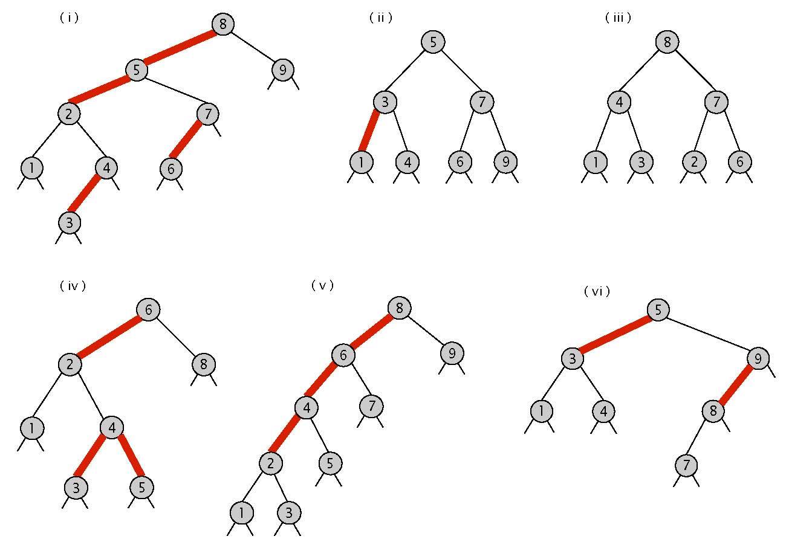
(b) Consider the following left-leaning red-black tree.
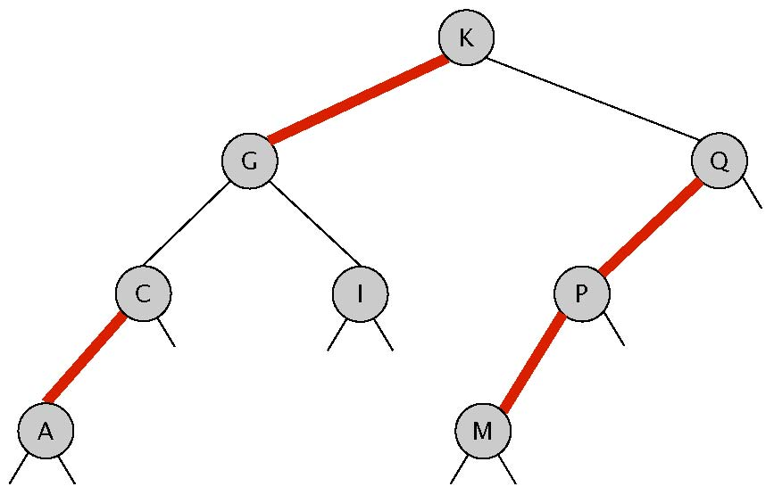
Add the key H, then add the key T. Draw the resulting left-leaning red-black tree.
7. Binary search trees. (8 points) Consider the following binary search tree method.
public Key mystery(Key key) { Node best = mystery(root, key, null); if (best == null) return null; return best.key;
}
private Node mystery(Node x, Key key, Node best) { if (x == null) return best; int cmp = key.compareTo(x.key); if (cmp < 0) return mystery(x.left, key, x); else if (cmp > 0) return mystery(x.right, key, best); else return x;
}
(a) What does mystery(key) return. Assume key is a data type value of the speciﬁed type and not null. Circle the best answer.
A. Predecessor: the largest key in the symbol table < the search key?
B. Floor: the smallest key in the symbol table ≤ the search key?
C. Ceiling: the smallest key in the symbol table ≥ the search key?
D. Successor: the smallest key in the symbol table > the search key?
E. Get: the key in the symbol table equal to the search key if it’s there; null otherwise.
F. Bad code: Null pointer exception or inﬁnite loop on some inputs.
(b) What is the worst-case number of compares for mystery()? Assume that the BST is balanced. Circle the best answer.

1 log NNN2 2N
8. Randomized queue. (10 points) For Assignment 2, you implemented a randomized queue that supported enqueue and de
queue (delete and return random) in amortized constant time (using space proportional to the number of items on the queue). Use a balanced binary search tree to implement the two operations in logarithmic time per
operation in the worst-case (using space proportional to the number of items on the queue).
Hint: simulate a dynamically resizable array using st.get(i), st.put(i, item), and st.delete(i). Use StdRandom.uniform(N) to generate a random integer between 0 and N − 1.
public class RandomizedQueue<Item> { private RedBlackBST<Integer, Item> st = new RedBlackBST<Integer, Item>();
// add the item to the queue public void enqueue(Item item) { int N = st.size();
// YOUR CODE HERE
}
// delete and return a random item from the queue
public Item dequeue() {
int N = st.size();
if (N == 0) throw new RuntimeException("Randomized queue underflow");
// YOUR CODE HERE
}
}

